# Numbering Olympic games in ascending order

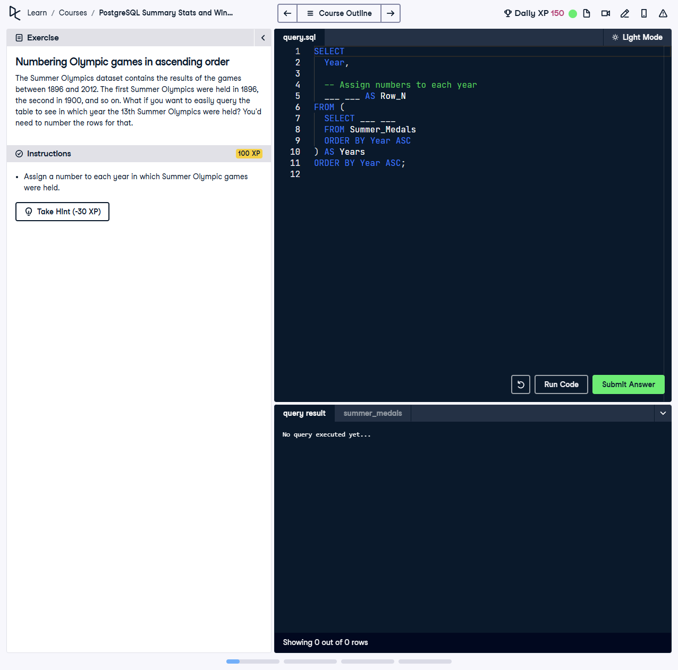

The Summer Olympics dataset contains the results of the games between 1896 and 2012. The first Summer Olympics were held in 1896, the second in 1900, and so on. What if you want to easily query the table to see in which year the 13th Summer Olympics were held? You’d need to number the rows for that.

This exercise involves assigning a number to each year in which the Summer Olympic games were held and then ordering them in ascending order. This allows querying specific years by their sequential number.

## Correct Answer

SELECT  
 Year,  
 ROW_NUMBER() OVER (ORDER BY Year ASC) AS Row_N  
FROM (  
 SELECT DISTINCT Year  
 FROM Summer_Medals  
 ORDER BY Year ASC  
) AS Years  
ORDER BY Year ASC;

Explanation of the query:

1. `SELECT DISTINCT Year FROM Summer_Medals`: Retrieves the unique years from the dataset where Summer Olympics were held.

2. `ROW_NUMBER() OVER (ORDER BY Year ASC) AS Row_N`: Assigns a sequential number to each unique year in ascending order.

3. Subquery `AS Years`: The inner query ensures the rows are distinct and ordered before assigning row numbers.

4. `ORDER BY Year ASC`: Ensures the final result is sorted by year in ascending order.